Suwannee Valley Transit Authority
Title VI Plan

Date Adopted: November 14, 2022
CONTENTS
Preface 1
Title VI/Nondiscrimination Policy Statement and Management Commitment to Title VI Plan 4
Introduction & Description of Services 5
Title VI Liaison 5
Alternate Title VI Contact 5
First Time Applicant Requirements 6
Annual Certifications and Assurances 7
Title VI Plan Adoption 7
Title VI Notice to the Public 8
Notice to the Public 8
Notice Posting Locations 8
Title VI Procedures and Compliance 9
Complaint Procedure 9
Complaint Form 9
Record Retention and Reporting Policy 9
Subrecipient Assistance and Monitoring 10
Contractors and Subcontractors 10
Nondiscrimination Clauses 10
Disadvantaged Business Enterprise (DBE) Policy 11
E-Verify 11
Title VI Investigations, Complaints, and Lawsuits 12
Public Participation Plan 13
Current Outreach Efforts 13
Language Assistance Plan 15
Transit Planning and Advisory Bodies 16
Title VI Equity Analysis 17
System-Wide Service Standards and Service Policies 18
Appendices 19
Appendix A FTA Circular 4702.1b Reporting Requirements for Transit Providers 20
Appendix B Current System Description 23
Appendix C Title VI Plan Adoption Meeting Minutes 26
Appendix D Title VI Sample Notice to Public 31
Appendix E Complaint Form 34
Appendix F Public Participation Plan 39
Appendix G Language Assistance Plan 43
Appendix H Operating Area Language Data: 49
Appendix I Demographic Maps 52
Appendix J Title VI Equity Analysis 56

TABLES
Table 1 | Summary of Investigations, Lawsuits, and Complaints 12
Table 2 | Transit Planning and Advisory Boards 16

Preface
This template has been developed by the Florida Department of Transportation (FDOT) District Two in coordination with the FDOT Central Office in order to assist transit agencies with the development of their Title VI Plan. Although each agency is different in size, organization structure, operations, etc., minimum Title VI compliance requirements are common to all. This template document is intended to assist smaller transit agencies that often do not have adequate resources to develop a Title VI Plan in accordance with the minimum requirements of Section 49 Code of Federal Regulations, Part 21 and Federal Transit Administration (FTA) Circular 4702.1B. It should be noted that this template covers the Title VI requirements for Subrecipient transit providers that operate less than 50 vehicles in peak service and are located in urbanized areas (UZA) of less than 200,000 population and rural transit providers.
While the development, adoption, and implementation of a Title VI Plan that complies, at a minimum, with the requirements set forth by FTA Circular 4702.1B is mandatory, the agencies have the prerogative to either utilize this template or enhance their existing Title VI Plan with the information contained in this document. If an agency decides to utilize this template, they will have to customize this document to fit their agency ensuring compliance with FTA Circular 4702.1B, adopt the document, and implement and comply with the Title VI Plan.
It is important to note that the Department is not requiring transit agencies to adopt this template. Transit agencies must, however, adopt a Title VI Plan which addresses all of the requirements of FTA Circular 4702.1B which apply to their agency. The intent of the Department was to develop a document which addresses the provisions of the circular and provide it to local transit agencies as a means of helping them reduce their administrative burden in preparing or updating their Title VI Plans. We believe this document will be invaluable to you in this regard. In developing this document, it was understood that some transit agencies may elect to adopt the template document as a whole with little customization. This decision is up to the local transit agency. It must be understood, however, that future compliance reviews will examine your policies and observed practices to ensure that they are consistent with the Title VI Plan you have adopted, and also compliant with FTA Circular 4702.1B.
To use this template, open the electronic file contained in the Title VI Plan Template CD in Microsoft Word and save the file with an appropriate name (e.g., “Suwannee Valley Transit Authority Bus System Title VI Plan.doc”). You will quickly note that the Template Document has been color coded to help you distinguish between the actual requirements of FTA Circular 4702.1B, and optional language we have provided that might assist you in developing your plan or elaborating on how your agency is addressing the requirements of FTA Circular 4702.1B.
Text Any text highlighted in yellow color should be replaced with your agency’s information.
Text Any text highlighted in blue color are instructions for completion of the template. Please delete all blue highlighted text prior to completion of the Plan.
Text appearing within the blue shaded boxes is informational only and may provide instructions or other information that will help you in customizing your Title VI Plan.

Text Any text appearing in green color represents optional or suggested language that may assist you in explaining or elaborating on how you are meeting the intent of the requirement.
Text appearing within the bordered boxes as well as the black text found within the section descriptions which follow, represent the actual requirements as stated in FTA Circular 4702.1B, or provides information directly related to the requirements.

Certain FTA Circular 4702.1B requirements are very prescriptive and the requirements are defined in great detail. Under these circumstances, it would be redundant to explain the requirements twice (once in the bordered box and then restate again within the general text that would follow). When such circumstances occur, it will be noted within the bordered box and the general text will be deferred to in summarizing the requirement.
Remember, in the context of FTA Circular 4702.1B, some requirements are not always prescriptive and detailed. Some portions of FTA Circular 4702.1B simply obligate the agency to define or develop a policy or procedure to explain how the agency will meet the intent of the requirement. The language the Department has developed in the green colored text is optional or example language crafted to assist you in these instances. You are not required to use it. Whether you elect to use the optional green text is entirely up to you, but please ensure that any green text utilized applies precisely to your agency. Regardless, your policy or procedure must comply with the requirements set forth by FTA Circular 4702.1B. Also, note that this Template is geared towards satisfying the requirements of FTA Circular 4702.1B only. You may have to incorporate additional policies and procedures to meet the requirements of other regulatory agencies, as appropriate. You can also customize the appendices as needed to supplement the Title VI Plan.
If you have any questions related to this document, please feel free to contact Ms. Doreen Joyner-Howard, AICP; District Two Modal Development Manager at doreen.joynerhoward@dot.state.fl.us or 904-360-5650.

Title VI Document Activity Log
Date | Activity  (Review/Update/Addendum/ Adoption/Distribution) | Concerned Person (Signature) | Remarks
04/15/2014 | Version 1 – created the template to assist the agencies | Doreen Joyner-Howard | Distributed to agencies via email
06/10/2022 | Version 2 – Updated language data tables and demographic maps using 2020 census data.  Changed “Your Community Transit” to “Suwannee Valley Transit Authority”. Added Spanish translation of Notice to the Public and Complaint Form.  Updated Appendix C to remove “FDOT Concurrence Letter”.  Added language to Appendix F to include strategies to engage hard-to-reach populations.  Changed JPA to PTGA. | Doreen Joyner-Howard | Distributed to agencies via email
11/14/2022 | Adopted by SVTA Board of Directors | Larry Sessions

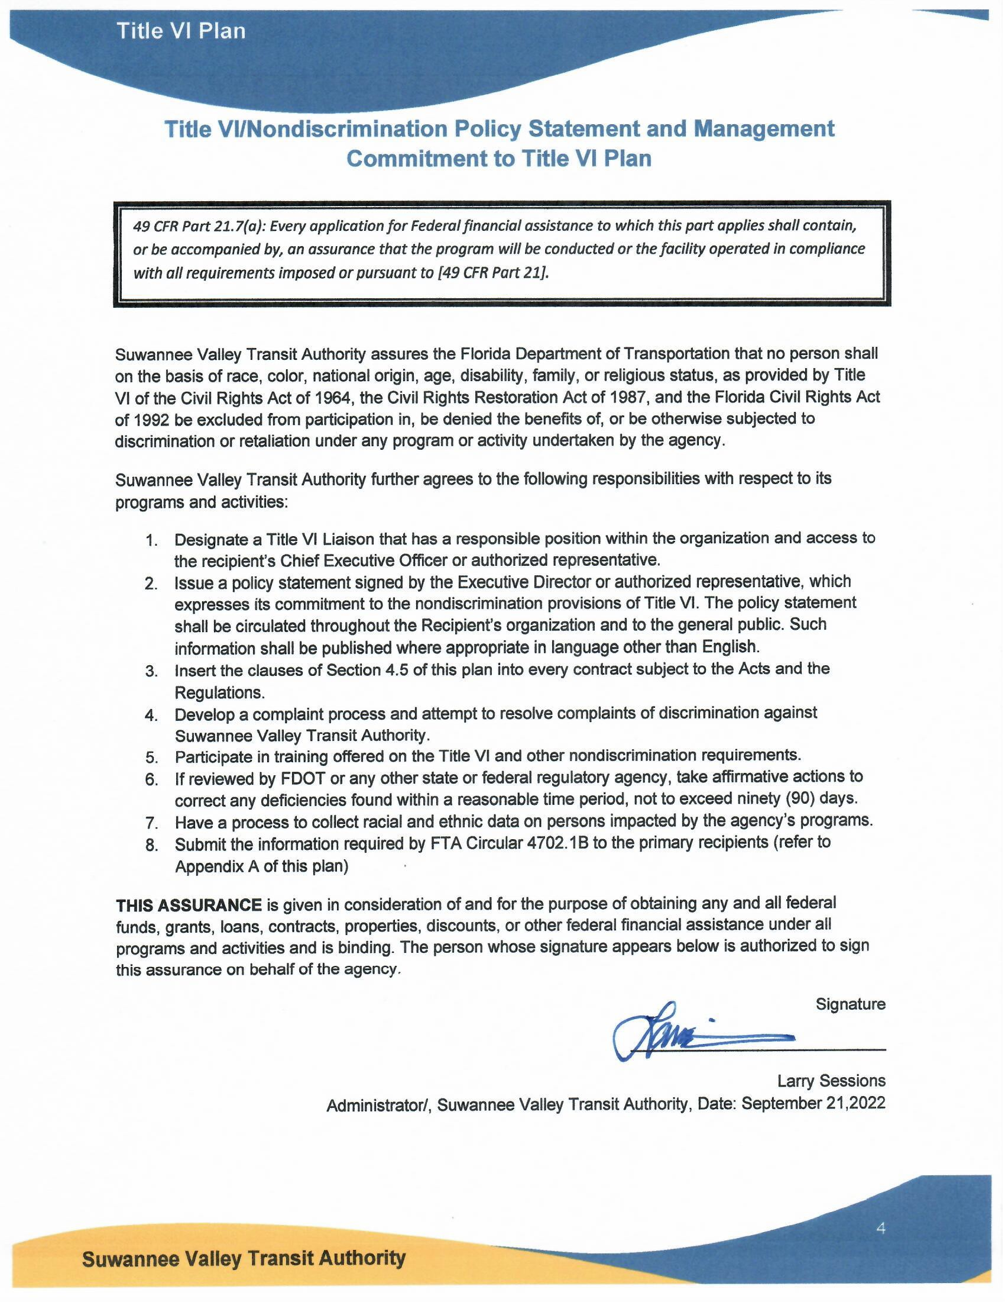
Administrator/, Suwannee Valley Transit Authority, Date: September 21,2022

Introduction & Description of Services
Suwannee Valley Transit Authority submits this Title VI Plan in compliance with Title VI of the Civil Rights Act of 1964, 49 CFR Part 21, and the guidelines of FTA Circular 4702.1B, published October 1, 2012.
Suwannee Valley Transit Authority is a Subrecipient of FTA funds and provides service in Columbia, Hamilton & Suwannee Counties. A description of the current Suwannee Valley Transit Authority system is included in Appendix B.

Title VI Liaison
Larry Sessions
Administrator
(386) 362-5332 ext. 6321
1907 Voyles Street, SW Live Oak, FL 32064

Alternate Title VI Contact
Teresa Fortner
Administrative Support
(386) 362-5332 ext. 6329
1907 Voyles Street, SW Live Oak, FL 32064
Suwannee Valley Transit Authority must designate a liaison for Title VI issues and complaints within the organization. The liaison is the focal point for Title VI implementation and monitoring of activities receiving federal financial assistance. Key responsibilities of the Title VI Liaison include:
- Maintain knowledge of Title VI requirements.
- Attend training on Title VI and other nondiscrimination authorities when offered by FDOT or any other regulatory agency.
- Disseminate Title VI information to the public including in languages other than English, when necessary.
- Develop a process to collect data related to race, gender and national origin of service area population to ensure low income, minorities, and other underserved groups are included and not discriminated against.
- Implement procedures for the prompt processing of Title VI complaints.

First Time Applicant Requirements

Suwannee Valley Transit Authority is not a first-time applicant for FTA/FDOT funding. The following is a summary of Suwannee Valley Transit Authority current and pending federal and state funding.
FTA Circular 4702.1B, Chapter III, Paragraph 3: Entities applying for FTA funding for the first time shall provide information regarding their Title VI compliance history if they have previously received funding from another Federal agency.

Current and Pending FTA Funding
1. [Section 5311 Grant], [06/05/2020 – 05/31/2023], [$398, 921], [Current]
2. [Section 5311 Grant], [06/05/2020 – 05/31/2023], [$85,111], [Current]
3. [Section 5311 Grant], [06/05/2020 – 05/31/2023], [$258,807], [Current]
4. [Section 5339 Grant – Capital], [2021/2021], [$153,519], [Current]
5. [Enhanced Mobility of Seniors and Individuals with Disabilities], [07/01/2021 – 03/31/2024], [$270,000], [Current]
6. [Section 5339 Grant – Capital], [2021/2022], [$212,592], [Pending]
7. [Section 5311 Grant – Capital], [2022/2023], [$199,736], [Pending]
9. [Section 5339 Grant – Capital], [2022/2023], [$199,736], [Pending]
Current and Pending FDOT Funding
1. [Commuter Assistance Program / Ride Share Grants], [03/17/2020 – 09/22/2022], [$60,000], [Current]
2. [Commuter Assistance Program / Ride Share Grants], [12/01/2021 – 11/30/2023], [$50,000], [Current]
Current and Pending Federal Funding (non-FTA)
1. [Formula Grants for Rural Areas], [06/09/2020 – 03/31/2023], [$2,380,380], [Current]
2. [Formula Grants for Rural Areas], [08/01/2022 – 08/31/2025], [$2,923,556], [Current]
Current and Pending State Funding (non-FDOT)
1. [Florida Commission for The Transportation Disadvantaged Trip & Equipment Grant], [07/01/2022 – 06/30/2023], [$702,246], [Current]
2. [Shirley Conroy Rural Area Capital Assistance Grant], [2022/2023], [$230,252], [Pending]
During the previous three years, Florida Department of Transportation did complete a Title VI compliance review of Suwannee Valley Transit Authority. Suwannee Valley Transit Authority has not been found to be in noncompliance with any civil rights requirements.
FTA Circular 4702.1B, Chapter III, Paragraph 2: Every application for financial assistance from FTA must be accompanied by an assurance that the applicant will carry out the program in compliance with the Title VI regulations.

The following is a summary of the compliance review.
- Date of the compliance review
September 26, 2019
- The purpose or reason for the review
FDOT Triennial Review
- Agency or organization that performed the review
Florida Department of Transportation
- Summary of the finding and recommendations of the review
There were no findings from the review.
- Report on the status of the findings and recommendations
N/A
- Current status of the compliance review
In compliance

Annual Certifications and Assurances
In accordance with 49 CFR Section 21.7(a), every application for financial assistance from FTA must be accompanied by an assurance that the applicant will carry out the program in compliance with Title VI regulations. This requirement shall be fulfilled when the applicant/recipient submits its annual certifications and assurances. Primary recipients will collect Title VI assurances from subrecipients prior to passing through FTA funds.
Suwannee Valley Transit Authority will remain in compliance with this requirement by annual submission of certifications and assurances as required by [FDOT] and/or [other primary recipient].

Title VI Plan Adoption
The Plan was approved and adopted by Suwannee Valley Transit Authority Board of Directors during a meeting held on November 4, 2013. A copy of the meeting minutes is included in Appendix C of this Plan.

Any additional text for Section 2 must be inserted above this point for formatting/page numbering purposes.

Title VI Notice to the Public
FTA Circular 4702.1B, Chapter III, Paragraph 5: Title 49 CFR 21.9(d) requires recipients to provide information to the public regarding the recipient’s obligations under DOT’s Title VI regulations and apprise members of the public of the protections against discrimination afforded to them by Title VI.

Notice to the Public
Recipients must notify members of the public of their rights under Title VI and include the notice and where it is posted in the Title VI Plan. The notice must include:
- A statement that the agency operates programs without regard to race, color, and national origin
- A description of the procedures members of the public should follow in order to request additional information on the grantee’s nondiscrimination obligations
- A description of the procedure members of the public should follow in order to file a discrimination complaint against the grantee
A sample of the notice is included in Appendix D of this Plan. The sample notice should be translated into other languages, as necessary.

Notice Posting Locations
The Notice to Public will be posted at many locations to apprise the public of Suwannee Valley Transit Authority obligations under Title VI and to inform them of the protections afforded them under Title VI. At a minimum, the notice will be posted in public areas of Suwannee Valley Transit Authority office(s) including the reception desk and meeting rooms, and on the Suwannee Valley Transit Authority website at www.ridesvta.com Additionally, Suwannee Valley Transit Authority will post the notice at stations, stops, and on transit vehicles.

Any additional text for Section 3 must be inserted above this point for formatting/page numbering purposes.

Title VI Procedures and Compliance
FTA Circular 4702.1B, Chapter III, Paragraph 6: All recipients shall develop procedures for investigating and tracking Title VI complaints filed aginst them and make their procedures for filing a complaint available to member of the public.

Complaint Procedure
Any person who believes he or she has been discriminated against on the basis of race, color, or national origin by Suwannee Valley Transit Authority may file a Title VI complaint by completing and submitting the agency’s Title VI Complaint Form (refer to Appendix E). Suwannee Valley Transit Authority investigates complaints received no more than 180 days after the alleged incident. Suwannee Valley Transit Authority will process complaints that are complete.
Once the complaint is received, Suwannee Valley Transit Authority will review it to determine if our office has jurisdiction. The complainant will receive an acknowledgement letter informing him/her whether the complaint will be investigated by our office.
Suwannee Valley Transit Authority has ninety (90) days to investigate the complaint. If more information is needed to resolve the case, Suwannee Valley Transit Authority may contact the complainant. The complainant has ten (10) business days from the date of the letter to send requested information to the investigator assigned to the case. If the investigator is not contacted by the complainant or does not receive the additional information within ten (10) business days, Suwannee Valley Transit Authority can administratively close the case. A case can also be administratively closed if the complainant no longer wishes to pursue their case.
After the investigator reviews the complaint, she/he will issue one of two letters to the complainant: a closure letter or a letter of finding (LOF). A closure letter summarizes the allegations and states that there was not a Title VI violation and that the case will be closed. A LOF summarizes the allegations and the interviews regarding the alleged incident, and explains whether any disciplinary action, additional training of the staff member, or other action will occur. If the complainant wishes to appeal the decision, she/he has seven (7) days to do so from the time he/she receives the closure letter or the LOF.
The complaint procedure will be made available to the public on Suwannee Valley Transit Authority website (www.ridesvta.com)

Complaint Form
A copy of the complaint form in English is provided in Appendix E and on Suwannee Valley Transit Authority (www.ridesvta.com).

Record Retention and Reporting Policy
FTA requires that all direct and primary recipients document their compliance by submitting a Title VI Plan to their FTA regional civil rights officer once every three (3) years. Suwannee Valley Transit Authority will submit their Title VI Plan to FDOT for concurrence on an annual basis or any time a major change in the Plan occurs.
Compliance records and all Title VI related documents will be retained for a minimum of three (3) years and reported to the primary recipient annually.

Subrecipient Assistance and Monitoring
Suwannee Valley Transit Authority does not have any subrecipients to provide monitoring and assistance. As a Subrecipient to FDOT, Suwannee Valley Transit Authority utilizes the Subrecipient assistance and monitoring provided by FDOT, as needed. In the future, if Suwannee Valley Transit Authority has subrecipients, it will provide assistance and monitoring as required by FTA Circular 4702.1B.

Contractors and Subcontractors (Not Applicable)
Suwannee Valley Transit Authority is responsible for ensuring that contractors are in compliance with Title VI requirements. Contractors may not discriminate in the selection and retention of any subcontractors. Subcontractors also may not discriminate in the selection and retention of any subcontractors. Suwannee Valley Transit Authority, contractors, and subcontractors may not discriminate in their employment practices in connection with federally assisted projects. Contractors and subcontractors are not required to prepare or submit a Title VI Plan. However, the following nondiscrimination clauses will be inserted into every contract with contractors and subcontractors subject to Title VI regulations.

Nondiscrimination Clauses
During the performance of a contract, the contractor, for itself, its assignees, and successors in interest (hereinafter referred to as the “Contractor”) must agree to the following clauses:
- Compliance with Regulations: The Contractor shall comply with the Regulations relative to nondiscrimination in Federally assisted programs of the U.S. Department of Transportation from time to time, (hereinafter referred to as the Regulations), which are herein incorporated by reference and made a part of this Agreement.
- Nondiscrimination: The Contractor, with regard to the work performed during the contract, shall not discriminate on the basis of race, color, national origin, sex, age, disability, religion, or family status in the selection and retention of subcontractors, including procurements of materials and leases of equipment. The Contractor shall not participate either directly or indirectly in the discrimination prohibited by section 21.5 of the Regulations, including employment practices when the contract covers a program set forth in Appendix B of the Regulations.
- Solicitations for Subcontractors, including Procurement of Materials and Equipment: In all solicitations made by the Contractor, either by competitive bidding or negotiation for work to be performed under a subcontract, including procurement of materials or leases of equipment; each potential subcontractor or supplier shall be notified by the Contractor of the subcontractor’s obligations under this contract and the Regulations relative to nondiscrimination on the basis of race, color, national origin, sex, age, disability, religion, or family status.
- Information and Reports: The Contractor shall provide all information and reports required by the Regulations or directives issued pursuant thereto, and shall permit access to its books, records, accounts, other sources of information, and its facilities as may be determined by the Florida Department of Transportation, the Federal Highway Administration, Federal Transit Administration, Federal Aviation Administration, and/or the Federal Motor Carrier Safety Administration to be pertinent to ascertain compliance with such Regulations, orders, and instructions. Where any information required of a Contractor is in the exclusive possession of another who fails or refuses to furnish this information, the Contractor shall so certify to the Florida Department of Transportation, the Federal Highway Administration, Federal Transit Administration, Federal Aviation Administration, and/or the Federal Motor Carrier Safety Administration as appropriate and shall set forth what efforts it has made to obtain the information.
- Sanctions for Noncompliance: In the event of the Contractor’s noncompliance with the nondiscrimination provisions of this contract, Suwannee Valley Transit Authority shall impose contract sanctions as appropriate, including, but not limited to:
  - withholding of payments to the Contractor under the contract until the Contractor complies, and/or
  - cancellation, termination, or suspension of the contract, in whole or in part.
- Incorporation of Provisions: The Contractor shall include the provisions of paragraphs 1 through 6 in every subcontract, including procurement of materials and leases of equipment, unless exempt by the Regulations, or directives issued pursuant thereto. The Contractor shall take such action with respect to any subcontract or procurement as the Suwannee Valley Transit Authority, Florida Department of Transportation, the Federal Highway Administration, Federal Transit Administration, Federal Aviation Administration, and/or the Federal Motor Carrier Safety Administration may direct as a means of enforcing such provisions including sanctions for noncompliance.

Disadvantaged Business Enterprise (DBE) Policy
As a part of the Public Transportation Grant Agreement (PTGA) with FDOT, Suwannee Valley Transit Authority and its contractors and subcontractors agree to ensure that Disadvantaged Business Enterprises as defined in 49 CFR Part 26, as amended, have the opportunity to participate in the performance of contracts. Suwannee Valley Transit Authority and its contractor and subcontractors shall not discriminate on the basis of race, color, national origin, or sex in the performance of any contract. The contractor shall carry out applicable requirements of 49 CFR Part 26 in the award and administration of FDOT-assisted contracts. Failure by the contractor to carry out these requirements is a material breach of this contract, which may result in the termination of the contract or such other remedy as the recipient deems appropriate.

E-Verify
As a part of the PTGA with FDOT, vendors and contractors of Suwannee Valley Transit Authority shall utilize the U.S. Department of Homeland Security’s E-Verify system to verify the employment eligibility of all new employees hired by the vendor or contractor while contracted with Suwannee Valley Transit Authority. Additionally, vendors and contractors shall expressly require any subcontractors performing work or providing services pursuant to work for Suwannee Valley Transit Authority shall likewise utilize the U.S. Department of Homeland Security’s E-Verify system to verify the employment eligibility of all new employees hired by the subcontractor while working for Suwannee Valley Transit Authority.

Any additional text for Section 4 must be inserted above this point for formatting/page numbering purposes.

Title VI Investigations, Complaints, and Lawsuits
FTA Circular 4702.1B, Chapter III, Paragraph 7: In order to comply with the reporting requirements of 49 CFR 21.9(b), FTA requires all recipients to prepare and maintain a list of any of the following that allege discrimination on the basis of race, color, or national origin: active investigations….; lawsuits, and complaints naming the recipient.

In accordance with 49 CFR 21.9(b), Suwannee Valley Transit Authority must record and report any investigations, complaints, or lawsuits involving allegations of discrimination. The records of these events shall include the date the investigation, lawsuit, or complaint was filed; a summary of the allegations; the status of the investigation, lawsuit, or complaint; and actions taken by Suwannee Valley Transit Authority in response; and final findings related to the investigation, lawsuit, or complaint. The records for the previous three (3) years shall be included in the Title VI Plan when it is submitted to [FDOT] and/or [other primary recipient].
Suwannee Valley Transit Authority has had no investigations, complaints, or lawsuits involving allegations of discrimination on the basis of race, color, or national origin over the past three (3) years. A summary of these incidents is recorded in Table 1.
Table 1 | Summary of Investigations, Lawsuits, and Complaints
 | Date (Month, Day, Year) | Summary (include basis of complaint: race color or origin) | Status | Action(s) Taken
Investigations
Lawsuits
 | March 12, 2021 | Race | Resolved | Mediation
Complaints

Any additional text for Section 5 must be inserted above this point for formatting/page numbering purposes

Public Participation Plan
FTA Circular 4702.1B, Chapter III, Paragraph 4.a.4: Every Title VI Plan shall include the following information: A public participation plan that includes an outreach plan to engage minority and limited English proficient populations, as well as a summary of outreach efforts made since the last Title VI Plan submission. A recipient’s targeted public participation plan of minority populations may be part of efforts that extend more broadly to include constituencies that are traditionally underserved, such as people with disabilities, low-income populations, and others.

The Public Participation Plan (PPP) for Suwannee Valley Transit Authority was developed to ensure that all members of the public, including minorities and Limited English Proficient (LEP) populations, are encouraged to participate in the decision-making process for Suwannee Valley Transit Authority. The PPP is included as Appendix F to this Title VI Plan.

Current Outreach Efforts
Suwannee Valley Transit Authority is required to submit a summary of public outreach efforts made over the last three (3) years. The following is a list and short description of Suwannee Valley Transit Authority recent, current, and planned outreached activities.
Date | Outreach description | Type of outreach
1/28/2019 | SVTA Board Meeting | Stakeholder mtg
2/20/2019 | Regional LCB Meeting | Stakeholder mtg
5/1/2019 | Regional LCB Meeting | Stakeholder mtg
5/13/2019 | SVTA Board Meeting | Stakeholder mtg
8/12/2019 | SVTA Board Meeting | Stakeholder mtg
8/14/2019 | Regional LCB Meeting | Stakeholder mtg
9/9/2019 | SVTA Board Meeting | Stakeholder mtg
11/4/2019 | SVTA Board Meeting | Stakeholder mtg
11/20/2019 | Regional LCB Meeting | Stakeholder mtg
11/25/2019 | SVTA Board Meeting | Stakeholder mtg
2/10/2020 | SVTA Board Meeting | Stakeholder mtg
2/19/2020 | Regional LCB Meeting | Stakeholder mtg
3/12/2020 | SVTA Board Meeting | Stakeholder mtg
4/7/2020 | SVTA Board Meeting | Stakeholder mtg
4/23/2020 | SVTA Board Meeting | Stakeholder mtg
4/29/2020 | SVTA Board Meeting | Stakeholder mtg
6/17/2020 | Regional LCB Meeting | Stakeholder mtg
8/10/2020 | SVTA Board Meeting | Stakeholder mtg
9/16/2020 | Regional LCB Meeting | Stakeholder mtg
11/16/2020 | SVTA Board Meeting | Stakeholder mtg
2/8/2021 | SVTA Board Meeting | Stakeholder mtg
2/17/2021 | Regional LCB Meeting | Stakeholder mtg
5/10/2021 | SVTA Board Meeting | Stakeholder mtg
5/19/2021 | Regional LCB Meeting | Stakeholder mtg
8/9/2021 | SVTA Board Meeting | Stakeholder mtg
9/15/2021 | Regional LCB Meeting | Stakeholder mtg
11/8/2021 | SVTA Board Meeting | Stakeholder mtg
11/17/2021 | Regional LCB Meeting | Stakeholder mtg
1/31/2022 | SVTA Board Meeting | Stakeholder mtg
2/16/2022 | Regional LCB Meeting | Stakeholder mtg
5/9/2022 | SVTA Board Meeting | Stakeholder mtg
5/18/2022 | Regional LCB Meeting | Stakeholder mtg
8/8/2022 | SVTA Board Meeting | Stakeholder mtg
9/21/2022 | Regional LCB Meeting | Stakeholder mtg

Any additional text for Section 6 must be inserted above this point for formatting/ page numbering purposes.

Language Assistance Plan
FTA Circular 4702.1B, Chapter III, Paragraph 9: Recipients shall take reasonable steps to ensure meaningful access to benefits, services, information, and other important portions of their programs and activities for individuals who are limited English proficient (LEP).

Suwannee Valley Transit Authority operates a transit system within Columbia, Hamilton and Suwannee Counties. The Language Assistance Plan (LAP) has been prepared to address Suwannee Valley Transit Authority responsibilities as they relate to the needs of individuals with Limited English Proficiency (LEP). Individuals, who have a limited ability to read, write, speak, or understand English are LEP. In Suwannee Valley Transit Authority service area there are 2,912 residents or 2.4% who describe themselves as not able to communicate in English very well (Source: US Census). Suwannee Valley Transit Authority is federally mandated (Executive Order 13166) to take responsible steps to ensure meaningful access to the benefits, services, information, and other important portions of its programs and activities for individuals who are LEP. Suwannee Valley Transit Authority has utilized the U.S. Department of Transportation (DOT) LEP Guidance Handbook and performed a four-factor analysis to develop its LAP. The LAP is included in this Title VI Plan as Appendix G.
Refer to the Language Data Tables--Copy and Paste applicable tables for your Agency service area in Appendix G.

Any additional text for Section 7 must be inserted above this point for formatting/page numbering purposes.

Transit Planning and Advisory Bodies
FTA Circular 4702.1B, Chapter III, Paragraph 10: Recipients that have transit-related, non-elected planning boards, advisory councils or committees, or similar committees, the membership of which is selected by the recipient, must provide a table depicting the racial breakdown of the membership of those committees, and a description of efforts made to encourage the participation of minorities on such committees.

The Suwannee Valley Transit Authority transit-related, advisory council consists of 4 members appointed by the Suwannee Valley Transit Authority Administrator.

Table 2 | Transit Planning and Advisory Boards
Body | Caucasian | Latino | African American | Asian American | Native American | Other
Service Area Population
Title VI Committee | 1 |  | 1 |  | 2
[Committee 2]
[Committee 3]

Suwannee Valley Transit Authority will make efforts to encourage minority participation on the committee.

Any additional text for Section 8 must be inserted above this point for formatting/page numbering purposes.

Title VI Equity Analysis
FTA Circular 4702.1B, Chapter III, Paragraph 4.a.8: If the recipient has constructed a facility, such as vehicle storage, maintenance facility, operation center, etc., the recipient shall include a copy of the Title VI equity analysis conducted during the planning stage with regard to the location of the facility.

Title 49 CFR, Appendix C, Section (3)(iv) requires that “the location of projects requiring land acquisition and the displacement of persons from their residences and business may not be determined on the basis of race, color, or national origin.” For purposes of this requirement, “facilities” does not include bus shelters, as they are considered transit amenities. It also does not include transit stations, power substations, or any other project evaluated by the National Environmental Policy Act (NEPA) process. Facilities included in the provision include, but are not limited to, storage facilities, maintenance facilities, operations centers, etc. In order to comply with the regulations, Suwannee Valley Transit Authority will ensure the following:
- Suwannee Valley Transit Authority will complete a Title VI equity analysis for any facility during the planning stage with regard to where a project is located or sited to ensure the location is selected without regard to race, color, or national origin. Suwannee Valley Transit Authority will engage in outreach to persons potentially impacted by the siting of the facility. The Title VI equity analysis must compare the equity impacts of various siting alternatives, and the analysis must occur before the selection of the preferred site.
- When evaluating locations of facilities, Suwannee Valley Transit Authority will give attention to other facilities with similar impacts in the area to determine if any cumulative adverse impacts might result. Analysis should be done at the Census tract or block group level where appropriate to ensure that proper perspective is given to localized impacts.
- If Suwannee Valley Transit Authority determines that the location of the project will result in a disparate impact on the basis of race, color, or national origin, Suwannee Valley Transit Authority may only locate the project in that location if there is a substantial legitimate justification for locating the project there, and where there are no alternative locations that would have a less disparate impact on the basis of race, color, or national origin. Suwannee Valley Transit Authority must demonstrate and document how both tests are met. Suwannee Valley Transit Authority will consider and analyze alternatives to determine whether those alternatives would have less of a disparate impact on the basis of race, color, or national origin, and then implement the least discriminatory alternative.

[Suwannee Valley Transit Authority has not recently constructed any facilities, nor does it currently have any facilities in the planning stage. Therefore, Suwannee Valley Transit Authority does not have any Title VI Equity Analysis reports to submit with this Plan. Suwannee Valley Transit Authority will utilize the demographic maps included in Appendix I for future Title VI analysis.]
Any additional text for Section 9 must be inserted above this point for formatting/page numbering purposes.
System-Wide Service Standards and Service Policies
FTA Circular 4702.1B, Chapter III, Paragraph 10: All fixed route transit providers shall set service standards and policies for each specific fixed route mode of service they provide.

Suwannee Valley Transit Authority is not a fixed route service provider.

Appendices

Appendix A FTA Circular 4702.1b Reporting Requirements for Transit Providers
Appendix B Current System Description
Appendix C Title VI Plan Adoption Meeting Minutes
Appendix D Title VI Sample Notice to Public
Appendix E Title VI Complaint Form
Appendix F Public Participation Plan
Appendix G Language Assistance Plan
Appendix H Operating Area Language Data: Suwannee Valley Transit Authority Service Area
Appendix I Demographic Maps
Appendix J Title VI Equity Analysis

Appendix A FTA Circular 4702.1b Reporting Requirements for Transit Providers

Every three years, on a date determined by FTA, each recipient is required to submit the following information to the Federal Transit Administration (FTA) as part of their Title VI Program. Subrecipients shall submit the information below to their primary recipient (the entity from whom the Subrecipient receives funds directly), on a schedule to be determined by the primary recipient.
General Requirements
All recipients must submit:
- Title VI Notice to the Public, including a list of locations where the notice is posted
- Title VI Complaint Procedures (i.e., instructions to the public regarding how to file a Title VI discrimination complaint)
- Title VI Complaint Form
- List of transit-related Title VI investigations, complaints, and lawsuits
- Public Participation Plan, including information about outreach methods to engage minority and limited English proficient populations (LEP), as well as a summary of outreach efforts made since the last Title VI Program submission
- Language Assistance Plan for providing language assistance to persons with limited English proficiency (LEP), based on the DOT LEP Guidance
- A table depicting the membership of non-elected committees and councils, the membership of which is selected by the recipient, broken down by race, and a description of the process the agency uses to encourage the participation of minorities on such committees
- Primary recipients shall include a description of how the agency monitors its subrecipients for compliance with Title VI, and a schedule of Subrecipient Title VI Program submissions
- A Title VI equity analysis if the recipient has constructed a facility, such as a vehicle storage facility, maintenance facility, operation center, etc.
- A copy of board meeting minutes, resolution, or other appropriate documentation showing the board of directors or appropriate governing entity or official(s) responsible for policy decisions reviewed and approved the Title VI Program. For state DOTs, the appropriate governing entity is the state’s Secretary of Transportation or equivalent. The approval must occur prior to submission to FTA.
- Additional information as specified in Sections IV, V, and VI, depending on whether the recipient is a transit provider, a state, or a planning entity (see below)

Requirements of Transit Providers N/A
All Fixed Route Transit Providers must submit:
- All requirements set out in Section III (General Requirements)
- Service standards
- Vehicle load for each mode
- Vehicle headway for each mode
- On time performance for each mode
- Service availability for each mode
- Service policies
- Transit Amenities for each mode
- Vehicle Assignment for each mode

Transit Providers that operate 50 or more fixed route vehicles in peak service and are located in an Urbanized Area (UZA) of 200,000 or more people must submit:
- Demographic and service profile maps and charts
- Demographic ridership and travel patterns, collected by surveys
- Results of their monitoring program and report, including evidence that the board or other governing entity or official(s) considered, was aware of the results, and approved the analysis
- A description of the public engagement process for setting the “major service change policy,” disparate impact policy, and disproportionate burden policy
- Results of service and/or fare equity analyses conducted since the last Title VI Program submission, including evidence that the board or other governing entity or official(s) considered, was aware of, and approved the results of the analysis

Appendix B Current System Description

Current System Description
- An overview of the organization including its mission, program goals, and objectives.
Suwannee Valley Transit Authority’s current and long-term focus as a transportation provider is on maintaining the best-coordinated transportation system possible for this community. Our goal is to create a coordinated system with the objective of providing safe, reliable, timely, and efficient transportation services to county residents.
- Organizational structure, type of operation, number of employees, service hours, staffing plan and safety and security plan.
Suwannee Valley Transit Authority is a non-profit. Our organization is made up of 21 full-time employees, 8 part-time employees, and 0 volunteers. Our Administrator is responsible for all of the day-to-day operations of our organization and reports directly to our Board Members. Our Board is committed to this program and has, therefore, incorporated our service within the tri-county Public Transportation Program. Transportation services are provided in accordance with the Board’s approved Operations Manual/System Safety/Security Program and its Transportation Disadvantaged Service Plan (TDSP). We will continue to operate at previous year (2021) service hours averaging 84 total fleet service hours per day or approximately 25,200 annual service hours (assuming 300 operating days).
- Indicate if your agency is a government authority or a private non-profit agency.
Suwannee Valley Transit Authority operates as a non-profit with a CTC agreement with the Commission of Transportation Disadvantaged. We have an executed CTC agreement dated July 1, 2021.
- Who is responsible for insurance, training and management, and administration of the agency’s transportation programs?
Suwannee Valley Transit Authority’s Administrator is responsible for training and management of our transportation program. All safety sensitive employees are required to complete FDOT approved safety and security training course as part of their new hire orientation. All new employees are required to complete behind the wheel training. The Administrator is responsible for annual renewal of all liability insurance for both FDOT and agency owned vehicles, as well as vehicle registration renewal. It is the Administrator’s responsibility to administer all aspects of the transportation program and to control access and usage of all agency vehicles.
- Who provides vehicle maintenance and record keeping?
Maintenance on all agency vehicles is provided by in-house mechanics. Suwannee Valley Transit Authority employs only ASE certified technicians with experience in working on commercial passenger vehicles like the type our agency uses. All maintenance is performed using the Preventative Maintenance Plan, which conforms to the state Vehicle Maintenance Guidelines set forth in the FDOT Preventative Maintenance Guidelines document. All vehicle files and driver files are kept on-site at our operations base located at 1907 Voyles Street, SW, Live Oak, FL 32064 and are maintained by the Maintenance Supervisor. All records are maintained and retained for a minimum of four (4) years.
- Number of current transportation related employees.
Our transportation department has a total of 29 employees that include: 9 full-time drivers, 8 part-time drivers, 1 administrator, and 11 support staff.

- Who will drive the vehicle, number of drivers, CDL certifications, etc.?
Only transportation employees that have completed all of the required safety and drivers training requirements will be allowed to drive the agency vehicles.
- A detailed description of service routes and ridership numbers.
Transportation services provided through our program are available to citizens of our service area. We provide a wide range of trip purposes that include: medical, nutrition, shopping, social service, training, employment, social and recreation. Currently, we use a variety of vehicles to provide passenger services. Our fleet includes vans, modified vans, and buses. 22 of our vehicles are equipped for wheelchair service. We prioritize grouping trips and multi-loading to the maximum extent possible.

Appendix C Title VI Plan Adoption Meeting Minutes

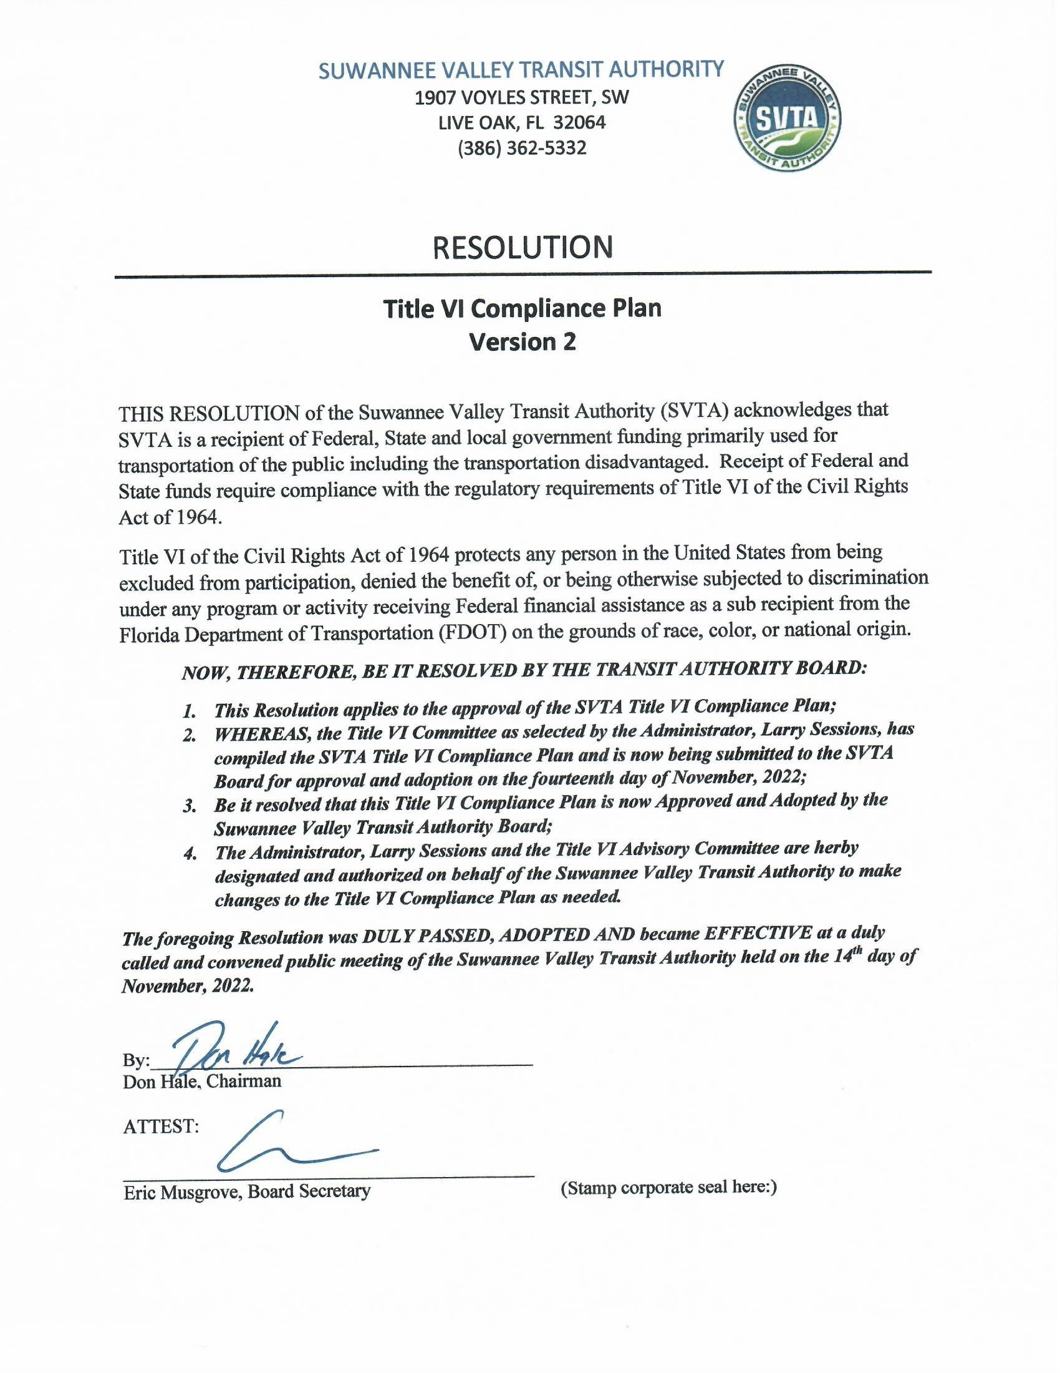
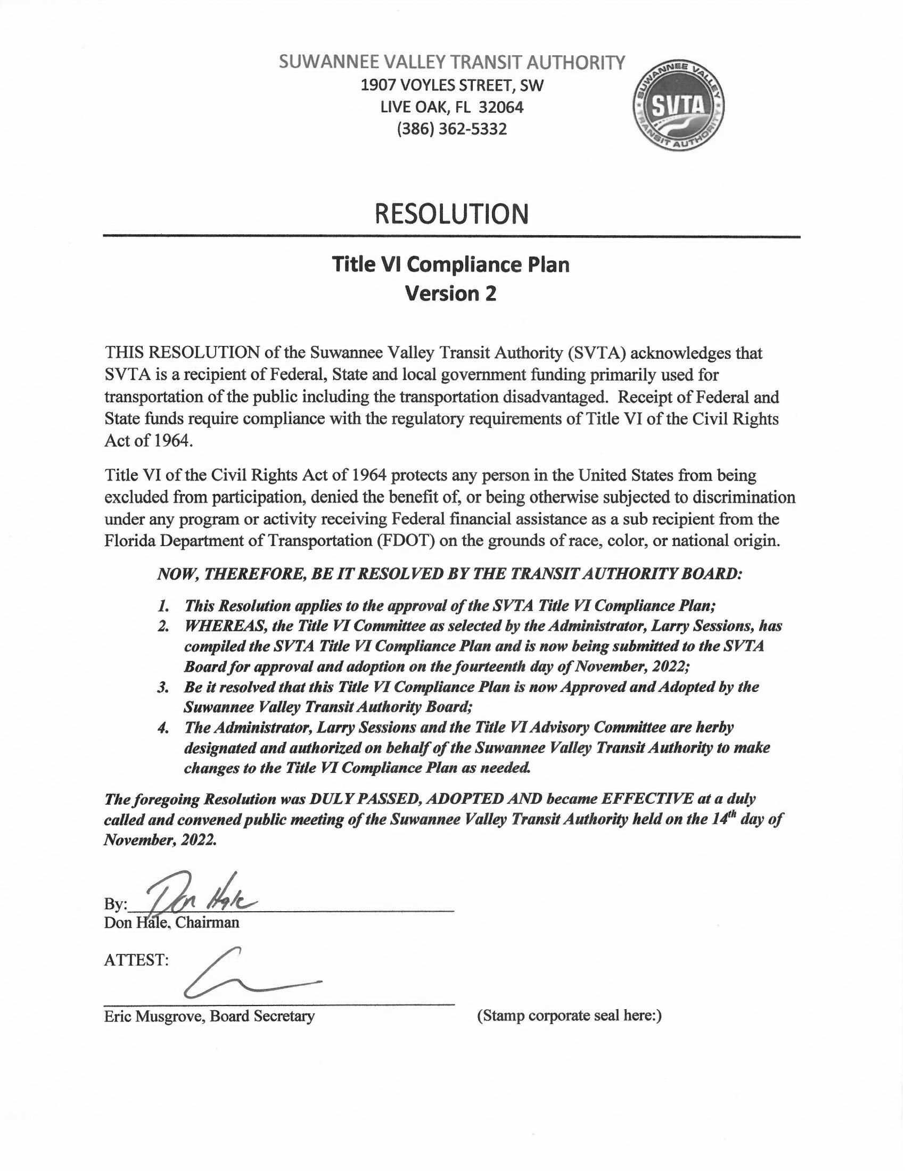

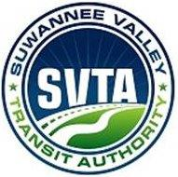

MINUTES

of the

GOVERNING BOARD OF DIRECTORS

OPENING:
The November 4, 2013 special called Meeting of the SVTA Board of Directors was called to order at 6:00 p.m. by Commissioner Philip Oxendine in the Conference Room of the Suwannee Valley Transit Authority. Chairman Ronald Williams was unable to attend the meeting; therefore, Commissioner Oxendine presided in his absence. The invocation was given by Commissioner Fleming and the flag salute was led by Commissioner Oxendine.

PRESENT:
Commissioners: Robert Brown, Clyde Fleming, Bucky Nash, Philip Oxendine, Josh Smith, Hal A. Airth, Board Attorney.

SVTA Agency Representatives: Gwendolyn Pra, Administrator; Bill Steele, Teresa Fortner, Sarai King, Wayne Blevins, Ken Kaemmer, Floyd Webb, DD Raggins, Cinda Foster, Shirley Cribbs, Frederica Johnson, Mark Holmes and Nick Furst.

Subcontractors present: Wade Greathouse, Alternative; Joanne Collins, Collins Transport; James Daniels and Laverne Johnson, D’s Healthcare; Brenda Littrell, Parrish.

Absent from the Meeting: Jason Bashaw was unable to attend due to a prior engagement.

VENDOR COMPLIANCE:
Mrs. Pra began the discussion on vendor compliance by stating the Board had granted the vendors 30 days to bring their vehicles into compliance and 90 days to bring their paperwork into compliance. She added the vendors have completed 75% to 80% of the paperwork.

Mrs. Pra encouraged the Board members to address the vendors and mechanics with any questions. There was an in depth discussion between the Board members, vendors and mechanics regarding compliance issues and ways to rectify the problems. The vendors explained how they were in the process of repairs and the cost factor involved. They also need additional time to complete their repairs in preparation for a final inspection.

Mr. Airth reminded the Board that in their September 23, 2013 Board meeting, a motion was voted on and passed to allow 30 days, not to exceed October 31, 2013, for the vendors to bring their vehicles into safety compliance. Of the 15 vehicles required to have inspections, 12 of those vehicles weren’t presented for their first inspection until after October 21, 2013. Mr. Airth stated the Board has a responsibility to the Agency and its riders and could become a liability issue.

Mrs. Pra explained SVTA is attempting to have all vehicles in compliance by the date
DOT will arrive for their final inspection. Even though SVTA’s vehicles are in compliance, if the vendor’s vehicles are not, SVTA will be cited for noncompliance. SVTA has worked diligently in preparing all vehicles for the DOT inspection to include the vendor’s and SVTA vehicles.

Commissioner Nash made a motion to extend an additional 30 days for vendors to have their redlined vehicles in compliance with the condition they will not use those redlined vehicles to transport riders until they have passed inspection. Commissioner Fleming seconded and motion carried (5-0).

Commissioner Oxendine cautioned the vendors not to use a redlined or uninspected vehicle. He also suggested the above motion be amended to include a letter the vendors will sign stating they will only transport riders in a vehicle that has passed inspection. This action is believed to take some of the liability off the SVTA Board in the event of an accident. Mr. Steele agreed with this amendment stating SVTA can use vehicle VIN numbers to assign trips and it will also provide needed documentation. The motion carried (5-0).

RESOLUTIONS:
- FFSB Line of Credit Increase: Discussed and approved.
- FFSB Credit Card Application: Discussed and approved.
- 5310 Grant-Capital 2014/2015: Discussed and approved.
- 5311 Grant-Operating 2014/2015: Discussed and approved.
- Title VI Compliance Plan 2014/2015: Mrs. Pra explained the Federal Transit Administration has recently required all transit authorities have this policy in place. She is asking the Board’s approval to submit the plan to DOT and give her the authority to make any minor changes, if requested, by DOT. Mrs. Pra also informed the Board of the appointments to the Title VI Committee to review the compliance plan, creating a policy statement and an advisory committee. There is also a requirement to address Limited English Proficiency (LEP) for any persons who speak little, or no, English. DOT will inform us if the submitted plan meets the federal requirements. Each rider will be presented with Title VI information and what it represents on an individual basis. SVTA will also keep a log of any Title VI complaints and will be brought before the Title VI Committee for discussion and respond to the rider. Commissioner Fleming made the motion to submit the Title VI Compliance Plan to DOT for approval and to give Mrs. Pra the make any necessary changes. Bucky Nash seconded and motion carried (5-0).

CLOSING COMMENTS:
Commissioner Fleming: Encouraged the vendors to have their vehicles in compliance. He questioned the vendors if they are in agreement with the Board granting an additional 30 days extension to bring their vehicles into compliance. James Daniels (D’s), Joanne Collins (Collin’s Transport), Brenda Littrell (Parrish) and Wade Greathouse (Alternative) were all in agreement with the extension, adding the safety issues for their riders is very important to them as well. He stated he would be stopping by SVTA to check on their progress for safety reasons and Mr. Blevins, Maintenance Supervisor, encouraged him to do so.

Commissioner Nash’s questions and comments:
- Agenda Placement: What is the protocol for someone requesting placement on the Agenda? Mrs. Pra explained their request should be forwarded directly to her. SVTA sets the agenda and it is approved by the Chairman.
- Vice Chairman: SVTA may want to consider a yearly appointment or reappointment of the Chairman and Board Members.

- Memorandum Agreement: Concerning a previous request for the agreement between the counties which he had not received. Mr. Steele explained the Memorandum Agreement is in the process of being rewritten, almost complete and will be presented to the Board Members prior to the December SVTA Board Meeting for review.
- Board Meetings: Desire to change to monthly Board Meetings indicating the difficulty in running an institution by the Board when meeting quarterly. Commissioner Oxendine stated he will be unable to attend monthly meeting due to scheduling conflicts but bimonthly would be acceptable if Board chooses.
- HMO’s: With the HMO’s taking over the Medicaid portion of SVTA’s transportation; the Board will need to stay informed of the changes. Mrs. Pra explained SVTA is communicating with the companies that will be responsible for contracting the trips which will be moved from SVTA to the Transportation Management Organization (TMO)’s. SVTA is also meeting with these companies and completing paperwork needed to sign a contract and she indicated a smooth transition. Commissioner Nash is concerned with the HMO revenue decrease along with need of a decrease in SVTA expenses. He also stated the outcome may be out of SVTA’s control since the funds will be provided by the HMO’s instead of Medicaid. Mrs. Pra assured to Board they would be informed of the progress SVTA is making with the TMO’s, which includes approximately 10 companies. The year-end plan is to know which, and how many, TMO’s SVTA will be signing a contract with and that information will be present to the Board.
- Animosity: He believes the local and regional boards have been dealt with regarding the animosity between them and SVTA, and additionally, to delete the animosity between the vendors and SVTA since he considers them to be as one unit for the maximum benefit of SVTA. The goal is to move forward, learning from past mistakes, among being the lack of oversight from the SVTA Board. He added he enjoyed everyone being open to comments and suggestions.

Commissioner Smith: Spoke of a problem between SVTA and the vendors indicating that being the purpose of his absence from SVTA’s Board meetings. According to him, there is a need to resolve the issues between the vendors and SVTA, to include the shop. He also states the problems are apparent at the Board meetings as tensions begin to arise quickly. His observation is the animosity isn’t with each other but from past issues. He expressed the desire to see the vendors in a more pleasant relationship with the SVTA administration. He also had a concern that Wayne Blevins, Maintenance Supervisor, should not be placed in the center of the hostility since he has a great many issues to deal with. Mr. Blevins had positive comments in reference to the vendors since he has been working with them in getting their vehicles into compliance.

Commissioner Oxendine: His suggestion to the Board is to hold off making a decision to change the meetings until the Memorandum Agreement is presented. He also indicated he may not be serving on the SVTA Board by the December, 2013 meeting due to the Suwannee Board of County Commissioner’s upcoming election. His belief is SVTA is moving forward in the right direction. He is disappointed the vendors didn’t comply with the Board’s 30 days extension previously set in bringing their vehicles into compliance. His concern remains with the safety factor.

Brenda Littrell (Parrish) stated she doesn’t have a problem with SVTA but in the event an issue does arise, she goes to Mrs. Pra to work out a solution. She also accepts responsibility for her vehicles being redlined.

Mr. Steele stated the Board hired Mrs. Pra giving her the responsibility of running the SVTA operations but does not allow her the authority to make those decisions. Often times, this places a state of confusion as to what the Board expects in allowing the company to move forward. He agrees the vendors are needed now and the future in moving forward with the HMO’s.

Mrs. Pra informed the Board the vendors are being included in SVTA’s resources when setting up contacts with the HMO’s. She also reminded the Board vendors have always received payment for their services in a timely manner and will continue to do so.

ADJOURNMENT:
Commissioner Oxendine asked for a motion to adjourn. Commissioner Nash made the motion, Commissioner Fleming seconded and Board carried (5-0). Adjournment was at 7:40 p.m.

The next SVTA Board Meeting is scheduled for December 9, 2013 at 6:00 p.m.

Respectfully submitted,

_________________________
(Mrs.) Shirley D. Cribbs,
Secretary to the Board

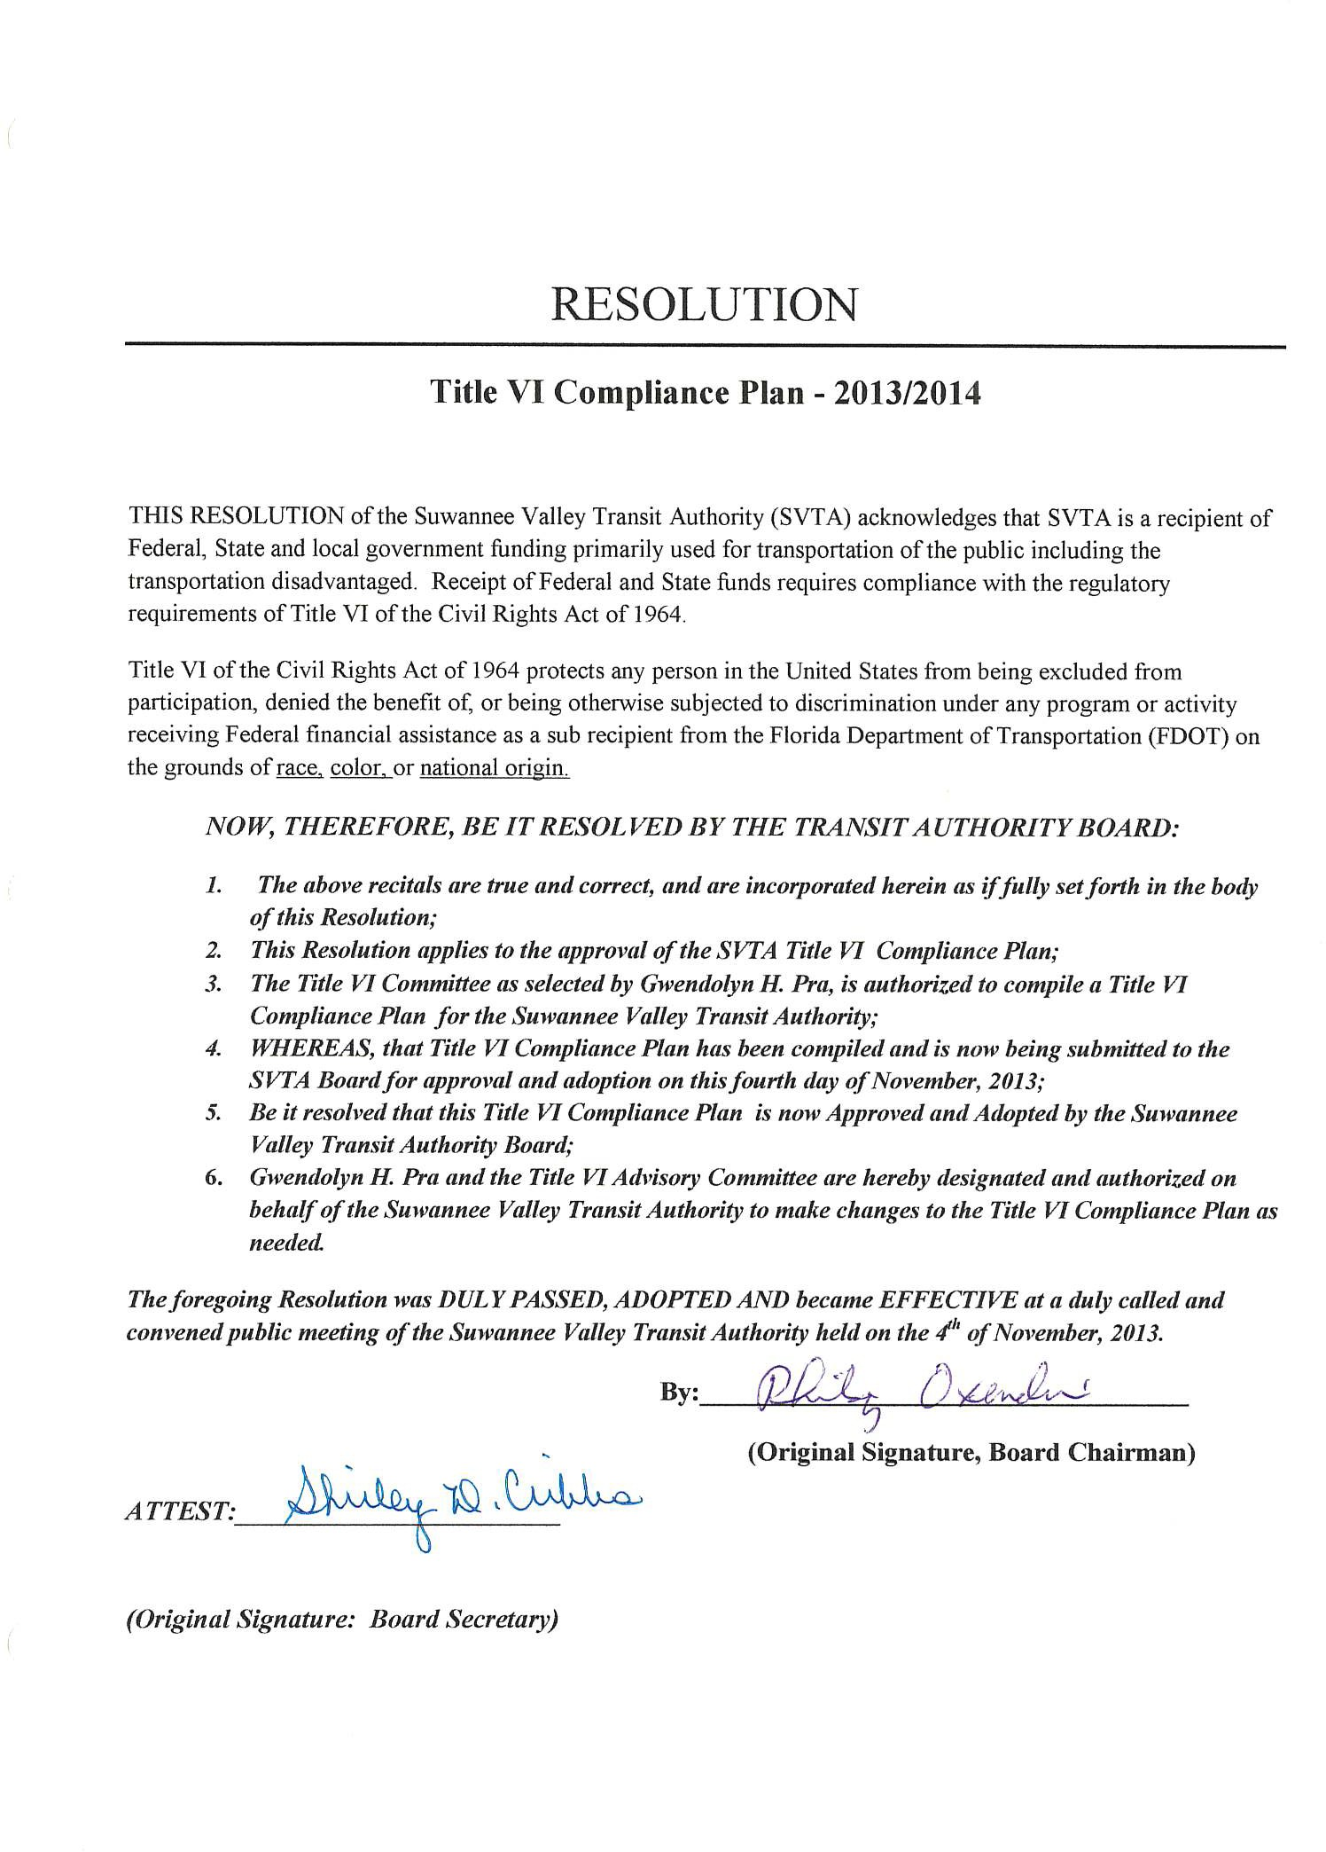

Appendix D Title VI Sample Notice to Public

Notifying the Public of Rights Under Title VI

SUWANNEE VALLEY TRANSIT AUTHORITY
- Suwannee Valley Transit Authority operates its programs and services without regard to race, color, and national origin in accordance with Title VI of the Civil Rights Act. Any person who believes she or he has been aggrieved by any unlawful discriminatory practice under Title VI may file a complaint with Suwannee Valley Transit Authority.
- For more information on Suwannee Valley Transit Authority’s civil rights program, and the procedures to file a complaint, contact 386 362-5332, email larry.sessions@ridesvta.com or visit our administrative office at 1907 Voyles Street, SW Live Oak, Florida 32064. For more information, visit www.ridesvta.com.
- If information is needed in another language, contact 386 362-5332.

Notificación al público de los derechos en virtud del Título VI

SUWANNEE VALLEY TRANSIT AUTHORITY
- Suwannee Valley Transit Authority opera sus programas y servicios sin tener en cuenta la raza, el color y el origen nacional de acuerdo con el Título VI de la Ley de Derechos Civiles. Cualquier persona que crea que ha sido agraviada por cualquier práctica discriminatoria ilegal bajo el Título VI puede presentar una queja ante Suwannee Valley Transit Authority.
- Para obtener más información sobre el programa de derechos civiles Suwannee Valley Transit Authority’s y los procedimientos para presentar una queja, comuníquese con 386 362-5332; envíe un correo electrónico larry.sessions@ridesvta.com; o visite nuestra oficina administrativa en 1907 Voyles Street, SW Live Oak, FL 32064. Para obtener más información, visite www.ridesta.com.
- Si necesita información en otro idioma, póngase en contacto con 386 362-5332

Appendix E Complaint Form

SUWANNEE VALLEY TRANSIT AUTHORITY
Title VI Complaint Form
Section I:
Name:
Address:
Telephone (Home): |  |  |  | Telephone (Work):
Electronic Mail Address:
Accessible Format Requirements? | Large Print |  |  |  |  | Audio Tape
 | TDD |  |  |  |  | Other
Section II:
Are you filing this complaint on your own behalf? |  |  |  |  |  |  | Yes* |  | No
*If you answered "yes" to this question, go to Section III.
If not, please supply the name and relationship of the person for whom you are complaining:
Please explain why you have filed for a third party:
Please confirm that you have obtained the permission of the aggrieved party if you are filing on behalf of a third party. |  |  |  |  |  |  | Yes |  |  | No
Section III:
I believe the discrimination I experienced was based on (check all that apply):
[ ] Race [ ] Color [ ] National Origin [ ] Age
[ ] Disability [ ] Family or Religious Status [ ] Other (explain) ____________________________
Date of Alleged Discrimination (Month, Day, Year): __________
Explain as clearly as possible what happened and why you believe you were discriminated against. Describe all persons who were involved. Include the name and contact information of the person(s) who discriminated against you (if known) as well as names and contact information of any witnesses. If more space is needed, please use the back of this form.
________________________________________________________________________
________________________________________________________________________
Section IV
Have you previously filed a Title VI complaint with this agency? |  |  |  |  |  |  | Yes | No

Section V
Have you filed this complaint with any other Federal, State, or local agency, or with any Federal or State court?
[ ] Yes [ ] No
If yes, check all that apply:
[ ] Federal Agency:
[ ] Federal Court [ ] State Agency
[ ] State Court [ ] Local Agency
Please provide information about a contact person at the agency/court where the complaint was filed.
Name:
Title:
Agency:
Address:
Telephone:
Section VI
Name of agency complaint is against:
Contact person:
Title:
Telephone number:

You may attach any written materials or other information that you think is relevant to your complaint.
Signature and date required below

Signature | Date

Please submit this form in person at the address below, or mail this form to:
Suwannee Valley Transit Authority
Larry Sessions, Administrator
1907 Voyles Street, SW
Live Oak, FL 32064

Sección I:
Nombre:
Dirección:
Teléfono (Inicio): |  |  |  | Teléfono (Trabajo):
Dirección de correo electrónico:
¿Requisitos de formato accesible? | Letra grande |  |  |  |  | Cinta de audio
 | TDD |  |  |  |  | Otro
Sección II:
¿Está presentando esta queja en su propio nombre? |  |  |  |  |  |  | Sí* |  | No
*Si respondió "sí" a esta pregunta, vaya a la Sección III.
De lo contrario, proporcione el nombre y la relación de la persona por la que se queja:
Por favor, explique por qué ha solicitado a un tercero:
Confirme que ha obtenido el permiso de la parte agraviada si está presentando una solicitud en nombre de un tercero. |  |  |  |  |  |  | Sí |  |  | No
Sección III:
Creo que la discriminación que experimenté se basó en (verifique todo lo que se aplica):
[ ] Raza[ ] Color[ ] Origen nacional [ ] Edad
[ ] Discapacidad [ ] Estado familiar o religioso [ ] Otro (explicar) _______________________________________
Fecha de la presunta discriminación (mes, día, año): __________
Explique lo más claramente posible lo que sucedió y por qué cree que fue discriminado. Describa a todas las personas que estuvieron involucradas. Incluya el nombre y la información de contacto de la(s) persona(s) que lo discriminó (si se conoce), así como los nombres y la información de contacto de cualquier testigo. Si se necesita más espacio, utilice la parte posterior de este formulario.
________________________________________________________________________
________________________________________________________________________
Sección IV
¿Ha presentado previamente una queja del Título VI ante esta agencia? |  |  |  |  |  |  | Sí | No

SUWANNEE VALLEY TRANSIT AUTHORITY
Formulario de reclamación del Título VI (Spanish)

Sección V
¿Ha presentado esta queja ante alguna otra agencia federal, estatal o local, o ante algún tribunal federal o estatal?
[ ] Sí[ ] No
En caso afirmativo, marque todo lo que corresponda:
[ ] Agencia Federal:
[ ] Tribunal Federal [ ] Agencia Estatal
[ ] Tribunal Estatal [ ] Agencia Local
Proporcione información sobre una persona de contacto en la agencia / tribunal donde se presentó la queja.
Nombre:
Título:
Agencia:
Dirección:
Teléfono:
Sección VI
El nombre de la queja de la agencia es contra:
Persona de contacto:
Título:
Número de teléfono:

Puede adjuntar cualquier material escrito u otra información que considere relevante para su queja.
Firma y fecha requeridas a continuación

Firma | Fecha

Envíe este formulario en persona a la dirección que aparece a continuación, o envíelo por correo a:
Suwannee Valley Transit Authority
Larry Sessions, Administrator
1907 Voyles Street, SW
Live Oak, FL 32064

Appendix F Public Participation Plan

The Public Participation Plan (PPP) is an open-ended plan which should be tailored to the needs and capabilities of your agency. The following is a rough template for a possible PPP for a typical subrecipient transit agency. The plan should be modified to match the public participation needs of your agency with capabilities of your agency. FTA Circular 4702.1B provides little concrete guidance to the contents of the PPP. The following are instructions from FTA Circular 4702.1B with regards to the PPP:
“Recipients have wide latitude to determine how, when, and how often specific public participation activities should take place, and which specific measures are most appropriate. Recipients should make these determinations based on a demographic analysis of the population(s) affected, the type of plan, program and/or service under consideration, and the resources available.”
“Some of those effective practices include:
- Scheduling meeting at times and locations that are convenient and accessible for minority and LEP communities.
- Employing different meeting sizes and formats.
- Coordinating with community and faith-based organizations, educational institutions, and other organizations to implement public engagement strategies that reach out specifically to members of affected minority and/or LEP communities.
- Considering radio, television, or newspaper ads on stations and in publications that serve LEP populations. Outreach to LEP populations could also include audio programming available on podcasts.
- Providing opportunities for public participation through means other than written communication, such as personal interviews or use of audio or video recording devices to capture oral communication. “

With these instructions in mind, please add or remove items from the template as you see fit. The majority of the plan is shown in green text to indicate the flexibility in the plan.
Additionally, the new Infrastructure Investment and Jobs Act (IIJA) does not require any direct changes to Title VI, it does offer opportunities for agencies to enhance their equity initiatives, such as enhanced community engagement and outreach to hard-to-reach populations. The following list of strategies can be considered to aid agencies in enhanced outreach:
- Partnering with churches and other community organizations that serve particular populations, including food banks, homeless shelters, and immigrant support organizations, is helpful for connecting with hard-to-reach communities. These organizations are trusted by community members and, particularly for immigrants, speak their languages.
- Advertising on Spanish-language radio and in Spanish-language newspapers were found to be cost-effective strategies for reaching the Hispanic community in several states.
- Messaging that directs individuals to assistance resources, includes personal testimonials, and emphasizes availability and benefits of service.
- Offering outreach and enrollment assistance at large community events, such as fairs and sporting events, provides opportunities to efficiently reach large numbers of people.

Introduction
The Public Participation Plan (PPP) for Suwannee Valley Transit Authority was developed to ensure that all members of the public, including minorities and Limited English Proficient (LEP) populations, are encouraged to participate in the decision-making process for Suwannee Valley Transit Authority. Policy and service delivery decisions need to take into consideration community sentiment and public opinion based upon well-executed outreach efforts. The public outreach strategies described in the PPP are designed to provide the public with effective access to information about Suwannee Valley Transit Authority services and to provide a variety of efficient and convenient methods for receiving and considering public comment prior to implementing changes to services. Suwannee Valley Transit Authority also recognizes the importance of many types of stakeholders in the decision-making process, including other units of government, community-based organizations, passengers, and the general public, including low-income, minority, LEP, and other traditionally underserved communities.
Public Participation Goals
The main goal of the PPP is to offer meaningful opportunities for all interested segments of the public, including, but not limited to, low-income, minority and LEP groups, to comment, about Suwannee Valley Transit Authority and its operations. The goals for this PPP include:
- Inclusion and Diversity: Suwannee Valley Transit Authority will proactively reach out and engage low-income, minority, and LEP populations for the Suwannee Valley Transit Authority service area so these groups will have an opportunity to participate.
- Accessibility: All legal requirements for accessibility will be met. Efforts will be made to enhance the accessibility of the public’s participation – physically, geographically, temporally, linguistically, and culturally.
- Clarity and Relevance: Issues will be framed in public meetings in such a way that the significance and potential effect of proposed decisions is understood by participants. Proposed adjustments to fares or services will be described in language that is clear and easy to understand.
- Responsive: Suwannee Valley Transit Authority will strive to respond to and incorporate, when possible, appropriate public comments into transportation decisions.
- Tailored: Public participation methods will be tailored to match local and cultural preferences as much as possible.
- Flexible: The public participation process will accommodate participation in a variety of ways and will be adjusted over time as needed.
Public Participation Methods
The methods of public participation included in this PPP were developed based upon best practices in conjunction with the needs and capabilities of Suwannee Valley Transit Authority. Suwannee Valley Transit Authority intends to achieve meaningful public participation by a variety of methods with respect to service and any changes to service.
Suwannee Valley Transit Authority will conduct community meetings and listening sessions as appropriate with passengers, employers, community based organizations, and advisory committees to gather public input and distribute information about service quality, proposed changes or new service options.
The public will be invited to provide feedback on the Suwannee Valley Transit Authority website www.ridesvta.com and all feedback on the site will be recorded and passed on to Suwannee Valley Transit Authority management. The public will also be able to call the Suwannee Valley Transit Authority office at 386-362-5332 during its hours of operation. Feedback collected over the phone will be recorded and passed on to Suwannee Valley Transit Authority management. Formal customer surveys to measure performance will be conducted periodically. The comments recorded as a part of these participation methods will be responded to as appropriate.
For all public meetings, the venue will be a facility that is accessible for persons with disabilities and, preferably, is served by public transit. If a series of meetings are scheduled on a topic, different meeting locations may be used, since no one location is usually convenient to all participants.
For community meetings and other important information, Suwannee Valley Transit Authority will use a variety of means to make riders and citizens aware, including some or all of the following methods:
- In-vehicle advertisement
- Posters or flyers in transit center
- Posting information on website
- Press releases and briefings to media outlets
- Communications to relevant elected officials
- Other methods required by local or state laws or agreements
All information and materials communicating proposed and actual service adjustments will be provided in English and any other language that meets the “safe harbor” criteria.
The LCB Meetings
The North Central Florida Planning Council conducts the LCB Meetings, quarterly.

Appendix G Language Assistance Plan

- Introduction
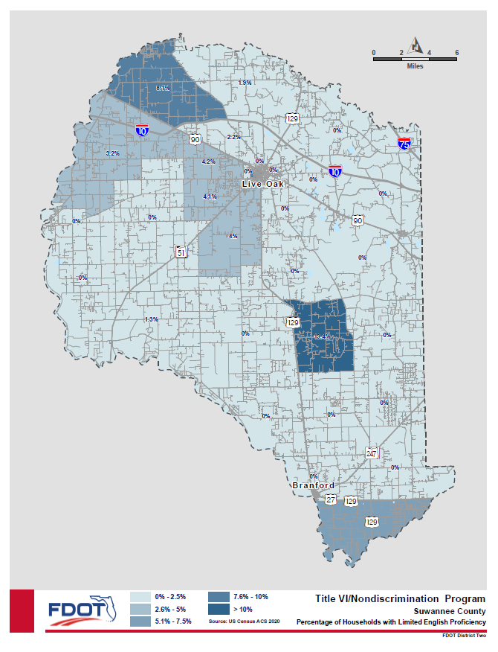
Suwannee Valley Transit Authority operates a transit system within Columbia, Hamilton and Suwannee Counties. The Language Assistance Plan (LAP) has been prepared to address Suwannee Valley Transit Authority’s responsibilities as they relate to the needs of individuals with Limited English Proficiency (LEP). Individuals, who have a limited ability to read, write, speak, or understand English are LEP. In Suwannee Valley Transit Authority service area there are 3.7% who describe themselves as not able to communicate in English “very well” (Source: US Census). Suwannee Valley Transit Authority is federally mandated (Executive Order 13166) to take responsible steps to ensure meaningful access to the benefits, services, information and other important portions of its programs and activities for individuals who are LEP. Suwannee Valley Transit Authority has utilized the U.S. Department of Transportation (USDOT) LEP Guidance Handbook and performed a four-factor analysis to develop its LAP.
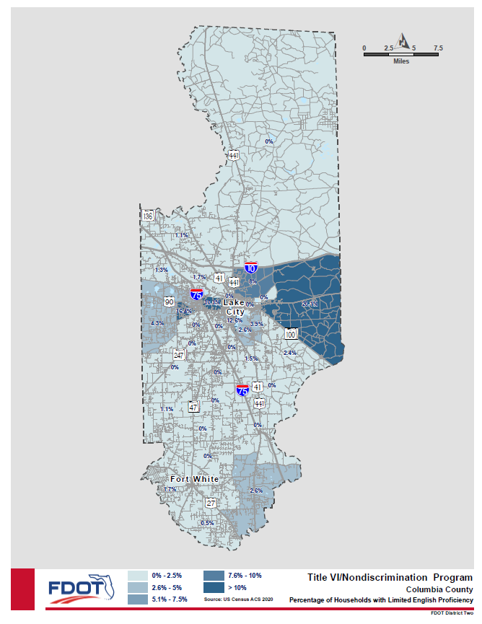

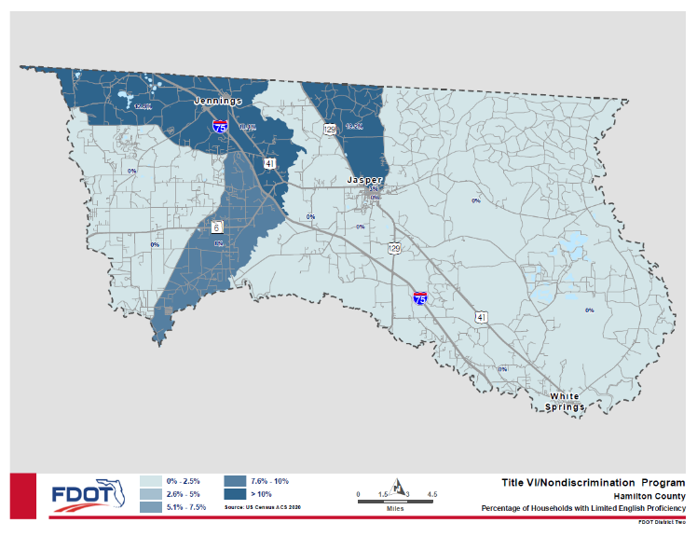

Refer to the Language Data Tables - Copy and Paste applicable tables for your Agency service area.
The U.S. Department of Transportation Handbook, titled “Implementing the Department of Transportation’s Policy Guidance Concerning Recipients’ Responsibilities to Limited English Proficient (LEP) Persons: A Handbook for Public Transportation Providers, (April 13, 2007)“ (hereinafter “Handbook”), states that Title VI of the Civil Rights Act of 1964, 42 U.S.C. 2000d et seq., and its implementing regulations provide that no person in the United States shall, on the grounds of race, color, or national origin, be excluded from participation in, be denied the benefits of, or be otherwise subjected to discrimination under any program or activity that receives Federal financial assistance (Handbook, page 5). The Handbook further adds that Title VI prohibits conduct that has a disproportionate effect on LEP persons because such conduct constitutes national origin discrimination (Handbook, page 5).
Executive Order 13166 of August 16, 2000, states that recipients of Federal financial assistance must take reasonable steps to ensure meaningful access to their programs and activities by LEP persons (Handbook, page 6). Additionally, recipients should use the DOT LEP Guidance to determine how best to comply with statutory and regulatory obligations to provide meaningful access to the benefits, services, information and other important portions of their programs and activities for individuals who are LEP (Handbook, page 6). These provisions are included in FTA Circular 4702.1B in Paragraph 9 of Section III (pages III-6 to III-9).
- Four Factor Analysis
The analysis provided in this report has been developed to identify LEP population that may use Suwannee Valley Transit Authority services and identify needs for language assistance. This analysis is based on the “Four Factor Analysis” presented in the Implementing the Department of Transportation’s Policy Guidance Concerning Recipients’ Responsibilities to Limited English Proficient (LEP) Persons, dated April 13, 2007, which considers the following factors:
1. The number and proportion of LEP persons in the service area who may be served or are likely to encounter a Suwannee Valley Transit Authority program, activity or service.
2. The frequency with which LEP persons come in contact with Suwannee Valley Transit Authority programs, activities or services.
3. The nature and importance of programs, activities or services provided by Suwannee Valley Transit Authority to the LEP population.
4. The resources available to Suwannee Valley Transit Authority and overall costs to provide LEP assistance:
  - Factor 1: The Number and Proportion of LEP Persons Serviced or Encountered in the Eligible Service Population
Of the 122,660 residents in the Suwannee Valley Transit Authority service area 2,912 residents describe themselves as speaking English less than “very well.” People of Hispanic descent are the primary LEP persons likely to utilize Suwannee Valley Transit Authority services. For the Suwannee Valley Transit Authority service area, the American Community Survey of the U.S. Census Bureau shows that among the area’s population 5.8% speak English “very well.” For groups who speak English “less than very well,” 82% speak Spanish and 8% speak Indo-European
Language one and two are the most spoken languages within your service area for the largest groups of LEP persons. Complete the table in Appendix H to determine langauge one and language two. Appendix H contains a table which lists the languages spoken at home by the ability to speak English for the population within the Suwannee Valley Transit Authority service area.
  - Factor 2: The Frequency with which LEP Individuals Come into Contact with Your Programs, Activities, and Services
The Federal guidance for this factor recommends that agencies should assess the frequency with which they have contact with LEP individuals from different language groups. The more frequent the contact with a particular LEP language group, the more likely enhanced services will be needed.
Suwannee Valley Transit Authority has assessed the frequency with which LEP individuals come in contact with the transit system. The methods utilized for this assessment include analysis of Census data, examining phone inquiries, requests for translated documents, and staff survey. As discussed above, Census data indicates that there is a lack of prominent LEP groups. Phone inquiries and staff survey feedback indicated that Suwannee Valley Transit Authority dispatchers and drivers interact infrequently with LEP persons. The majority of these interactions have occurred with LEP persons who mainly spoke Spanish. Over the past 3 years, Suwannee Valley Transit Authority has had 0 requests for translated documents.
  - Factor 3: The Nature and Importance of the Program, Activity, or Service Provided by the Recipient to People’s Lives
Public transportation and regional transportation planning is vital to many people’s lives. According to the Department of Transportation’s Policy Guidance Concerning Recipient’s Responsibilites to LEP Persons, providing public transportation access to LEP persons is crucial. A LEP person’s inability to utilize public transportation effectively, may adversely affect his or her ability to access health care, education, or employment.
  - Factor 4: The Resources Available to the Recipient and Costs
- Language Assistance Plan
In developing a Language Assistance Plan, FTA guidance recommends the analysis of the following five elements:
- Identifying LEP individuals who need language assistance
- Providing language assistance measures
- Training staff
- Providing notice to LEP persons
- Monitoring and updating the plan

The five elements are addressed below:
  - Element 1: Identifying LEP Individuals Who Need Language Assistance
Federal guidance provides that there should be an assessment of the number or proportion of LEP individuals eligible to be serviced or encountered and the frequency of encounters pursuant to the first two factors in the four-factor analysis.
Suwannee Valley Transit Authority has identified the number and proportion of LEP individuals within its service area using United States Census data (see Appendix H). As presented earlier, 91% of the service area population speaks English only. The largest non-English spoken language in the service area is Spanish. Of those who primary spoken language is Spanish 82% identify themselves as speaking less than “very well.” Those residents whose primary language is not English or Spanish as speaking English less than “very well” account for 8% of the service area population.
  - Element 2: Language Assistance Measures
Federal Guidance suggests that an effective LAP should include information about the ways in which language assistance will be provided. This refers to listing the different language services an agency provides and how staff can access this information.
For this task Federal Guidance recommends that transit agencies consider developing strategies that train staff as to how to effectively deal with LEP individuals when they either call agency centers or otherwise interact with the agency.
  - Element 3: Training Staff
Federal guidance states staff members of an agency should know their obligations to provide meaningful access to information and services for LEP persons and that all employees in public contact positions should be properly trained.
Suggestions for implementing Element 3 of the Language Assistance Plan, involve: (1) identifying agency staff likely to come into contact with LEP individuals; (2) identifying existing staff training opportunities; (3) providing regular re-training for staff dealing with LEP individual needs; and (4) designing and implementing LEP training for agency staff.
In the case of Suwannee Valley Transit Authority, the most important staff training is for Customer Service Representatives and transit drivers
  - Element 4: Providing Note to LEP Persons
Suwannee Valley Transit Authority will make Title VI information available in English and Spanish on the Agency’s website. Key documents are written in English and Spanish. Notices are also posted in Suwannee Valley Transit Authority office lobby and on buses.
Element 5: Monitoring and Updating the Plan
The plan will be reviewed and updated on an ongoing basis. Updates will consider the following:
- The number of documented LEP person contacts encountered annually
- How the needs of LEP persons have been addressed
- Determination of the current LEP population in the service area
- Determination as to whether the need for translation services has changed
- Determine whether Suwannee Valley Transit Authority’s financial resources are sufficient to fund language assistance resources needed

Suwannee Valley Transit Authority understands the value that its service plays in the lives of individuals who rely on this service, and the importance of any measures undertaken to make the use of system easier. Suwannee Valley Transit Authority is open to suggestions from all sources, including customers, Suwannee Valley Transit Authority staff, other transportation agencies with similar experiences with LEP communities, and the general public, regarding additional methods to improve their accessibility to LEP communities.
- Safe Harbor Provision
DOT has adopted the Department of Justice’s Safe Harbor Provision, which outlines circumstances that can provide a “safe harbor” for recipients regarding translation of written materials for LEP population. The Safe Harbor Provision stipulates that, if a recipient provides written translation of vital documents for each eligible LEP language group that constitutes five percent (5%) or 1,000 persons, whichever is less, of the total population of persons eligible to be served or likely to be affected or encountered, then such action will be considered strong evidence of compliance with the recipient’s written translation obligations. Translation of non-vital documents, if needed, can be provided orally. If there are fewer than 50 persons in a language group that reaches the five percent (5%) trigger, the recipient is not required to translate vital written materials but should provide written notice in the primary language of the LEP language group of the right to receive competent oral interpretation of those written materials, free of cost.
Suwannee Valley Transit Authority service does not have LEP populations which qualify for the Safe Harbor Provision. [As shown in Appendix H, Suwannee Valley Transit Authority does not have LEP groups which speak English less than “very well” which exceed either 5.0% or 1,000 person.] or [As shown in Appendix H, XXXXX speakers qualify for the Safe Harbor Provision as the number of person which speak English less than “very well” is counted as XX.X% and X,XXX persons.]
Using the Langauge data tables provided for your service area, review the total number and percentage for the Speak English less than “Very Well” category for each language. Any language which exceeds 1,000 people or 5% of the service area population, must be listed above as qualifying for the Safe Harbor Provision.
N/A

Appendix H Operating Area Language Data:

Suwannee Valley Transit Authority Service Area

Limited English Proficiency Table 2020 Census
 | Columbia County, FL | Hamilton County, FL | Suwannee County, FL
Label | Estimate | Estimate | Estimate
Total: | 66,680 | 13,778 | 42,205
Native: | 64,101 | 13,116 | 40,066
Speak only English | 61,146 | 12,146 | 38,006
Speak Spanish: | 2,203 | 676 | 1,410
Speak English "very well" | 1,891 | 547 | 1,316
Speak English "well" | 201 | 114 | 75
Speak English "not well" | 60 | 15 | 19
Speak English "not at all" | 51 | 0 | 0
Speak other Indo-European languages: | 621 | 200 | 617
Speak English "very well" | 597 | 168 | 593
Speak English "well" | 24 | 0 | 24
Speak English "not well" | 0 | 32 | 0
Speak English "not at all" | 0 | 0 | 0
Speak Asian and Pacific Island languages: | 78 | 19 | 23
Speak English "very well" | 51 | 19 | 23
Speak English "well" | 27 | 0 | 0
Speak English "not well" | 0 | 0 | 0
Speak English "not at all" | 0 | 0 | 0
Speak other languages: | 53 | 75 | 10
Speak English "very well" | 53 | 75 | 10
Speak English "well" | 0 | 0 | 0
Speak English "not well" | 0 | 0 | 0
Speak English "not at all" | 0 | 0 | 0
Foreign born: | 2,579 | 662 | 2,139
Speak only English | 797 | 77 | 448
Speak Spanish: | 1,059 | 306 | 1,492
Speak English "very well" | 494 | 19 | 493
Speak English "well" | 240 | 116 | 282
Speak English "not well" | 271 | 101 | 444
Speak English "not at all" | 54 | 70 | 273
Speak other Indo-European languages: | 346 | 252 | 66
Speak English "very well" | 271 | 180 | 44
Speak English "well" | 38 | 22 | 22
Speak English "not well" | 37 | 50 | 0
Speak English "not at all" | 0 | 0 | 0
Speak Asian and Pacific Island languages: | 363 | 27 | 133
Speak English "very well" | 169 | 0 | 118
Speak English "well" | 184 | 22 | 15
Speak English "not well" | 10 | 0 | 0
Speak English "not at all" | 0 | 5 | 0
Speak other languages: | 14 | 0 | 0
Speak English "very well" | 0 | 0 | 0
Speak English "well" | 14 | 0 | 0
Speak English "not well" | 0 | 0 | 0
Speak English "not at all" | 0 | 0 | 0

Appendix I Demographic Maps

Include the demographic maps applicable to your Agency’s service area- 8 maps per county in your service area

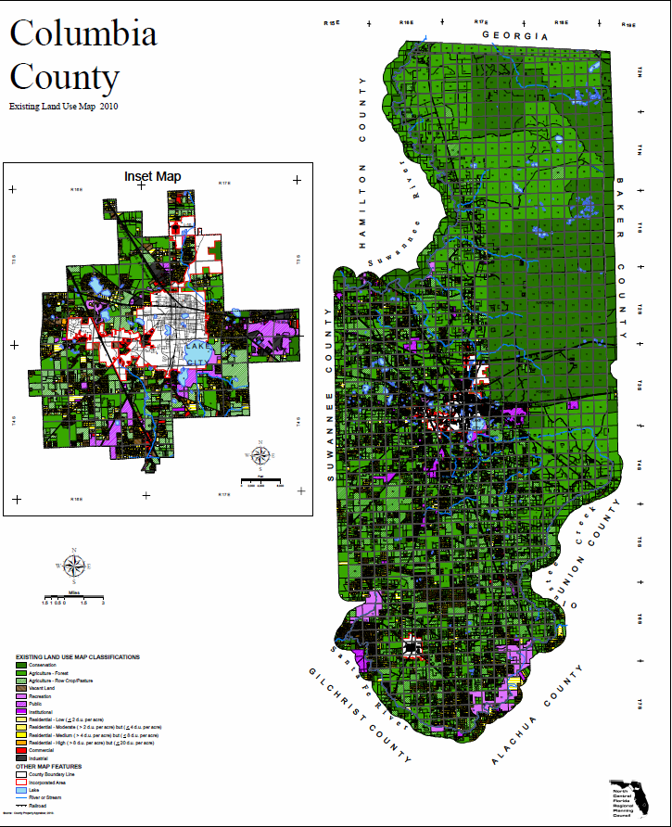

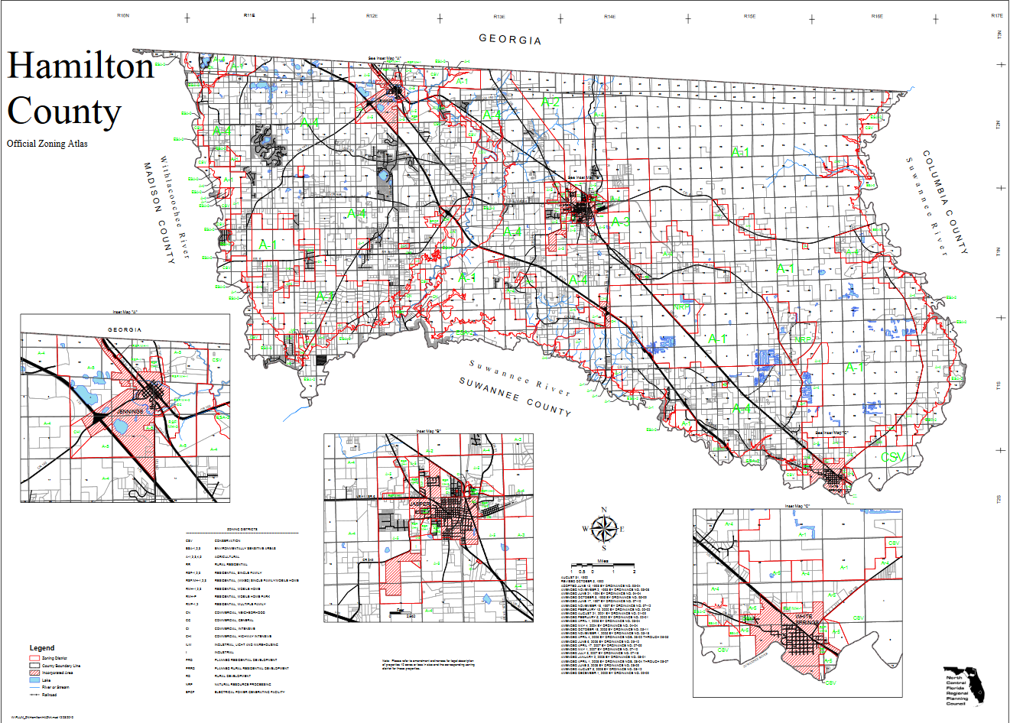

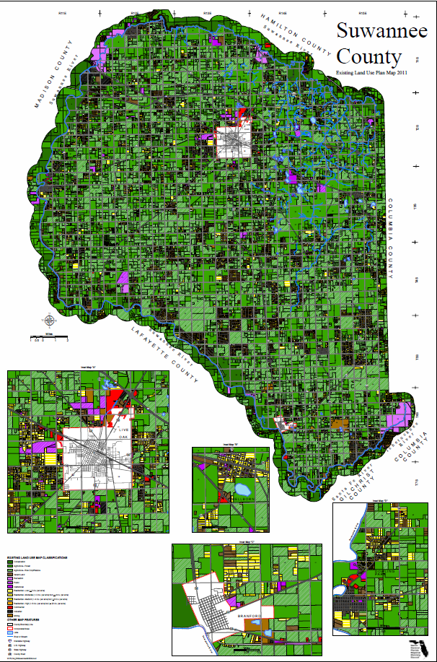

Appendix J Title VI Equity Analysis

Suwannee Valley Transit Authority has not performed Title VI Equity Analysis.

Doreen Joyner-Howard, AICP
Modal Development Manager
Florida Department of Transportation, District Two
Phone: (904) 360-5650
Email: doreen.joynerhoward@dot.state.fl.us

